MODELLING AND ANALYSIS OF CELLULAR STEEL BEAMS

FARZAD KHAN CHOWDHURY

UNIVERSITI TEKNOLOGI MALAYSIA
PSZ 19:16 (Pind. 1/13)
UNIVERSITI TEKNOLOGI MALAYSIA

DECLARATION OF THESIS / UNDERGRADUATE PROJECT REPORT AND COPYRIGHT
Author’s full name : Farzad Khan Chowdhury

Date of Birth : 21.10.2001

Title : MODELLING AND ANALYSIS OF CELLULAR STEEL BEAMS

Academic Session :

I declare that this thesis is classified as:

 | CONFIDENTIAL | (Contains confidential information under the Official Secret Act 1972)*
 | RESTRICTED | (Contains restricted information as specified by the organization where research was done)*
 | OPEN ACCESS | I agree that my thesis to be published as online open access (full text)

- I acknowledged that Universiti Teknologi Malaysia reserves the right as follows:
  - The thesis is the property of Universiti Teknologi Malaysia
  - The Library of Universiti Teknologi Malaysia has the right to make copies for the purpose of research only.
  - The Library has the right to make copies of the thesis for academic exchange.
 |  |  | Certified by:
 | Farzad
 | SIGNATURE OF STUDENT |  | SIGNATURE OF SUPERVISOR
 | A21MJ0138 |  | DR. HALINAWATI HIROL
 | MATRIX NUMBER |  | NAME OF SUPERVISOR
 | Date: 22 JUNE 2025 |  | Date: 22 JUNE 2025

NOTES : If the thesis is CONFIDENTIAL or RESTRICTED, please attach with the letter from the organization with period and reasons for confidentiality or restriction

“I hereby declare that we have read this thesis and in my
opinion this thesis is suffcient in term of scope and quality for the
award of the degree of Bachelor of Computer Science (Software Engineering) with Honors”

Signature | : | ________________________________
Name of Supervisor | : | HALINAWATI HIROL
Date | : | 22 June 2025

MODELLING AND ANALYSIS OF CELLULAR STEEL BEAMS

FARZAD KHAN CHOWDHURY

A thesis submitted in fulfilment of the
requirements for the award of the degree of
Bachelor of Computer Science (SOFTWARE ENGINEERING) with Honours

MALAYSIA-JAPAN INTERNATIONAL INSTITUTE OF TECHNOLOGY
Universiti Teknologi Malaysia

JUNE 2025

DECLARATION

I declare that this thesis entitled “Modelling and Analysis of Cellular steel beams” is the result of my own research except as cited in the references. The thesis has not been accepted for any degree and is not concurrently submitted in candidature of any other degree.
Signature | : | .............Farzad.......................................
Name | : | FARZAD KHAN CHOWDHURY
Date | : | 22 June 2025

DEDICATION

This thesis is dedicated to my father, who taught me that the best kind of knowledge to have is that which is learned for its own sake. It is also dedicated to my mother, who taught me that even the largest task can be accomplished if it is done one step at a time.

ACKNOWLEDGEMENT
In preparing this thesis, I was in contact with many people, researchers, academicians, and practitioners. They have contributed towards my understanding and thoughts. In particular, I wish to express my sincere appreciation to my main thesis supervisor, Professor Dr. Halinawati Hirol, for encouragement, guidance, critics and friendship. Without the continued support and interest, this thesis would not have been the same as presented here. My fellow student should also be recognised for their support. My sincere appreciation also extends to all my colleagues and others who have provided assistance at various occasions. Their views and tips are useful indeed. Unfortunately, it is not possible to list all of them in this limited space. I am grateful to all my family member.

ABSTRACT
Cellular steel beams are widely used in modern structural engineering due to their high strength-to-weight ratio, efficient material usage, and ability to accommodate building services. These beams, which feature regularly spaced circular web openings, present unique challenges in structural analysis—particularly in accurately assessing stress distribution and deflection. Traditional manual finite element analysis from ABAQUS is time-consuming in general, tedious and error-prone, particularly when handling multiple configurations. The project tackles these challenges by designing a fully automatic simulation and analysis system using Python script for ABAQUS. All the functionality is available through a cyclic Graphical User Interface (GUI) developed with Tkinter to be able to use it quickly. The system automatically creates the 3D beam model, which is then automatically meshed when submitted. It loads, runs the simulation in ABAQUS noGUI mode, and visualizes performance measures including maximum Von Mises stress and vertical deflection. These results are saved into a CSV file and presented on the GUI as well as a safe decision according to well-known design rules. The system allows productivity to be dramatically increased and also lowers the level of skill that is necessary to perform accurate structural simulations. It enables fast and sequential testing of different beam function theories, configurations, and facilitates data-driven decision-making. The framework also lays future integration of optimization methods, such as genetic algorithms (GA), for automatic determination of the optimum and structurally safe designs. In general, a useful guide for students, engineers, and modelers in the computational design field.

ABSTRAK
Balok keluli selular digunakan secara meluas dalam kejuruteraan struktur moden kerana nisbah kekuatan kepada beratnya yang tinggi, penggunaan bahan yang efisien, dan keupayaannya untuk menampung perkhidmatan bangunan. Balok ini, yang mempunyai bukaan bulat secara berkala pada bahagian jaringnya, menimbulkan cabaran unik dalam analisis struktur—terutamanya dalam menilai taburan tegasan dan lenturan dengan tepat. Pemodelan unsur terhingga secara manual menggunakan perisian seperti ABAQUS sering mengambil masa, berulang, dan terdedah kepada kesilapan, terutamanya apabila menganalisis pelbagai konfigurasi. Projek ini menangani cabaran tersebut dengan membangunkan sistem simulasi dan penilaian yang sepenuhnya automatik menggunakan skrip Python yang diintegrasikan dengan ABAQUS. Antara muka pengguna grafik (GUI) telah dibangunkan menggunakan Tkinter bagi menyediakan platform yang mudah dan interaktif untuk pengguna memasukkan parameter reka bentuk seperti diameter dan jarak lubang. Setelah dihantar, sistem ini secara automatik menjana model 3D balok, mengenakan syarat sempadan dan beban, menjalankan simulasi dalam mod noGUI ABAQUS, dan mengekstrak penunjuk prestasi utama seperti tegasan Von Mises maksimum dan lenturan menegak. Keputusan ini disimpan dalam fail CSV dan dipaparkan melalui GUI, bersama dengan keputusan keselamatan berdasarkan kriteria reka bentuk yang telah ditetapkan. Sistem ini meningkatkan produktiviti dengan ketara dan mengurangkan tahap kepakaran yang diperlukan untuk menjalankan simulasi struktur yang tepat. Ia membolehkan ujian pantas pelbagai konfigurasi balok dan memudahkan proses membuat keputusan berdasarkan data. Kerangka ini juga menyediakan asas untuk integrasi teknik pengoptimuman pada masa hadapan, seperti Algoritma Genetik (GA), bagi mengenal pasti reka bentuk yang paling efisien dan selamat dari segi struktur. Secara keseluruhan, alat ini berfungsi sebagai sumber yang bernilai bagi pelajar, jurutera, dan penyelidik dalam bidang analisis struktur dan automasi reka bentuk.

TABLE OF CONTENTS
 | TITLE | PAGE

DECLARATION ii
DEDICATION iii
ACKNOWLEDGEMENT iv
ABSTRACT v
ABSTRAK vi
TABLE OF CONTENTS vii
LIST OF TABLES ix
LIST OF FIGURES x
LIST OF ABBREVIATIONS xi
LIST OF SYMBOLS xii
LIST OF APPENDICES xiii

CHAPTER 1
1.1 Introduction 1
1.2 Problem Background 2
1.3 Research Aim - 3
1.4 Research Question 3
1.5 Research Objective 4
1.6 Research Scope 5
1.7 Research Contribution 6
1.8 Research Organization 7

CHAPTER 2
2.1 Introduction 8
2.2 Finite element Analysis 9
2.2.1 Example of FEA Software for structural eng. 10
2.2.2 Abaqus 11
2.3 Automation with Python scripts 11
2.4 GUI Based Tools for structural design 12
2.5 Limitations Of Traditional Manual Analysis 12
2.6 Use of AI And machine learning in structural opitmizatiom 13
2.7 Summary 13

Chapter 3
3.1 Introduction 15
3.2 Tools and Technologies used 16
3.3 Workflow Overview 17
3.4 Detailed Model Description 18
3.5 GUI Development 19
3.6 Optimization using Genetic algorithm 21

Chapter 4
4.1 Introduction 22
4.2 Usage Of Python 23
4.2.1 For automation 23
4.3 Data Collection and Testing 24
4.3.1 Sample Collection 24-25
4.3.2 Sample Size 25
4.3.3 Testing protocols 26-28
4.4 Expected Result 28

Chapter 5
5.1 Introduction 31
5.2 Simulation outputs 32
5.3 GUI Integration 34
5.4 Sample Table results 35
5.5 Result Interpretation 36
Chapter 6
6.1 Introduction 38
6.2 Future work 39
References 41-42

LIST OF TABLES
TABLE NO. | TITLE | PAGE
Table 5.5 Threshold table 37
Table 5.4 Results table 35
Table 1.1 Research Contribution 06

LIST OF FIGURES
FIGURE NO. | TITLE | PAGE
Figure 5.1 Deflection vs hole diameter 33
Figyre 5.2 Deflection vs hole spacing 33
Figure 5.3 Safe vs Unsafe results 35
Figure 3.1 Cellular steel beam 18
Figure 3.2 GUI for automated cellular beam simulation system 19
Figure 3.3 GUI with results 20

LIST OF ABBREVIATIONS
FEA | - | Finite Element Analysis
GA | - | Genetic Algorithm
GUI | - | Graphical User Interface
MPa | - | Megapascal (unit of stress)
U3 | - | Displacement in the vertical (Y) direction in ABAQUS
CSV | - | Comma-Separated Values
UTM | - | Universiti Teknologi Malaysia
mm | - | Millimetre
D | - | Hole Diameter
S | - | Hole spacing
CAE | - | Computer-Aided Engineering
ODB | - | Output Database
Safe/Unsafe | - | Structural safety verdict based on stress and deflection
YES/NO | - | Safety Classification output
L/120 | - | Deflection limit based on beam length

LIST OF SYMBOLS
L | - | Length of the beam(mm)
D | - | Diameter of the circular holes(mm)
S | - | Spacing between circular holes(mm)
h | - | Height of the beam(mm)
b | - | Width of the beam(mm)
E | - | Youngs Modulus (MPa)
ν | - | Poisson ration
σmax​ | - | Maximum Von mises stress (MPa)
σy​ | - | Yield strength of the material (MPa)
δmax​ | - | Maximum Vertical deflection(mm)
δallow | - | Allowable deflection-typically l/120(mm)
A | - | Cross-sectional area (mm^2)
f | - | Applied load or pressure (MPa)

LIST OF APPENDICES
APPENDIX | TITLE | PAGE
Appendix A GUI CODE 43-48
Appendix B AUTOMATION CODE 49-53
Appendix C OPTIMIZATION WITH GA CODE 54-55

INTRODUCTION

Introduction
Cellular steel beams are structural members that feature a series of regularly spaced circular openings along their web. These beams are commonly used in modern buildings, industrial floors, and bridges due to their advantages in weight reduction, cost efficiency, and flexibility in accommodating mechanical and electrical services. Despite their benefits, the presence of openings introduces complex stress patterns and deflection behaviour, which require detailed structural analysis to ensure safety and performance. Traditional analysis using finite element tools such as ABAQUS involves a manual and repetitive process—creating geometry, assigning materials, applying loads and boundary conditions, generating mesh, and extracting results for each design variation. This method is very time-consuming and does not make it feasible to design, therefore it is often possible to search through a massive number of design configurations, especially when considering the influence of different hole sizes and pitch. To address these limitations, this project is based on the creation of an automatic simulation system in Python scripting integrated with ABAQUS. A GUI was also developed, considering the characteristics listed above, due to which a new CAD interface was designed to provide users a friendly interaction in order to enter gain design parameters and real-time visualization of simulation results. The system supports structural safety evaluation by featuring the maximum Von Mises stress and the deflection, each configuration being categorized as safe or unsafe according to pre-set criteria. Moreover, the project paves the way for optimization that employs genetic algorithms (GA), that allow for automated search of the most effective and structurally sound beam configurations, and with a large decrease of the time and effort engaged in structural study, this system is intended to enhance the capacities and reduce the time and cost of assemblage for various projects of different applications as a simulator for students, engineers, and researchers in terms of capability, quality, and accessibility.

1.2 Problem Background
Cellular steel beams are known for their high strength-to-weight ratio and aesthetically appealing form, they are largely underdetermined by anisotropic materials. Anisotropic materials exhibit ΔA = Anisotropy, which are difficult problems to tackle in the prediction of response stemming from their composite geometry and material characteristics. Traditional designing with a material whose response is not known accurately and the methods of analysis tend to become overly conservative, or unsafe designs are produced. Good laboratory testing is accurate, but expensive and time-consuming. There is a need for advanced modelling methodologies like finite element analysis (FEA) with an optimization algorithm to optimize the performance of the petticoat, predictive chemotherapy, and efficiency of cellular steel beams. By systematically studying, investigating, and optimizing geometric and material parameters, the intent is to derive practical design recommendations for structural safety and shell stability of large shell-type construction efficiency while eliminating the drawbacks of the conventional method.

1.3 Research Aim
In this study, the ultimate objective is to highlight the structural performance of cellular steel beams to reflect a real-scale numerical model implemented by the finite element analysis through Abaqus. Cellular steel beams, characterized by their unique web openings, offer significant advantages in terms of weight reduction and material efficiency, making them a popular choice in modern construction. However, their complex geometry presents challenges in predicting their structural performance accurately. The purpose of this study is to improve knowledge of the mechanical properties, stress distribution, and failure mechanisms of the cellular steel beam under different loading conditions. By developing a 3D cellular steam beam model in Abaqus, simulating practical scenarios including static and dynamic loadings, this research will investigate the response mechanism of the beam and the most influential factors leading to its failure.
Finally, the proposed research will lead to enhanced design guidelines for cellular steel beams and further development of design methodologies to provide both safer and more economic engineering structural solutions.

1.4 Research Question
How to optimize geometric parameters and advanced algorithms to enhance the structural efficiency and safety of a cellular steel beam under different loading conditions?

1.5 Research Objectives
The objectives of this research are –
- To automate the creation of a finite element model of cellular steel beams by means of Abaqus and Python scripting.
- To investigate the load-carrying behaviour of cellular steel beams under different loading conditions.
- To use a genetic algorithm to design cellular steel beams effectively and safely.

1.6 Research Scope
This work is focused on the holistic modelling, assessment, and optimization of cellular steel beams with several important aspects. The investigations start from modelling the cellular steel beam and from the explanation of the new type of joint, while examining the behaviour of these beams subjected to compression, shear, and bending. Finite Element Analysis (FEA) methods are used to predict performance features including buckling modes, shear distribution, and bending response.
The effect of the geometric parameters (i.e., the cell size, shape, and spacing) on the structural behaviour of the beams is investigated. These parameters are systematically studied based on advanced computer modelling and database-driven methods. This also involves the establishment of a database where the results of the simulations can be compared for the initial stages of design and trends can be identified. Eventually, it attempts to improve the design of cellular steel beams by employing material resulting in efficient structure and minimizing material utilization while satisfying safety requirements. The optimization process will consist of iteratively refining with the help of algorithms like Genetic Algorithms until an optimal trade-off between cost-effectiveness and performance is reached.

1.7 Research Contribution
Table – 1.1 Research Contribution
No. | Contribution | Description
1 | Automation of Beam Simulation | Python scripting with Abaqus enables automatic modelling and simulation of cellular steel beams based on user input [5],[7].[8].
2 | User-friendly Interface | A Tkinter based GUI allows users to enter beam parameters and view results without needing FEA expertise [10], [12].
3 | Safety Evaluation | The system evaluates stress and deflection, and automatically classifies the design as safe or unsafe based on standard limits [4],[17].
4 | Optimization Framework | A genetic algorithm (GA) module is proposed to find the most efficient and safe beam configuration [13],[15],[17].

1.8 Report Organization
Chapter 1 provides the background to the study, the statement of the problems, research aims, research questions, and project’s contributions..

Chapter 2 provides a review of existing literature on cellular steel beams, finite element analysis (FEA) using ABAQUS, Python-based automation, GUI Development and structural optimization techniques.

Chapter 3 describes the methodology of the research used in the present work, details about the tools and the software that have been utilized, the workflow of the simulation and the process of beam modelling, the development of the GUI, and the optimization technique used through GAs.

Chapter 4 the implementation of the automated system is provided, discussing how Python scripting, GUI, and ABAQUS were combined to automate the simulation process for the beam.

Chapter 5 the responses obtained from the simulation system are presented, and the structural performance under different beam layouts is addressed, as well as overall trends and safety assessments.

Chapter 6 concludes the project with an overall summary of what has been done and what could be done to improve the system in the future in terms of optimization modules, GUI improvements, and transitioning the project to a web-based system.

LITERATURE REVIEW

Introduction
Cellular beams are being used more and more in modern construction because not only do they offer the structural engineer a tailor-made solution for long-span applications, but they also facilitate the integration of services and the overall project design. These beams are industrially produced and have had either circular or sinusoidal holes cut on their web that, besides being a means to reduce weight, also form cavities for the installation of the HVAC ducts, electrical conduits, and piping [1], [2]. That makes them perfect for long-span applications, such as floors and roofs in commercial buildings. But those openings alter the stress distribution and complicate the structural action. Previous work has demonstrated that the hole size and hole-to-hole spacing are of great relevance to the global stiffness, buckling resistance, and failure type of such beams [3], [13]. Simplified models have been derived to model this behaviour [4], and previous works investigated the influence of the variation of hole shapes on the beam performance [3]. These investigations emphasize the necessity of care in the design and analysis of cellular beams, despite their design advantages.

2.2 Finite Element Analysis
Finite element analysis (FEA) is a numerical method for predicting how structures will react to various forces, including loads, heat, and vibration, among other physical conditions. It works by cutting a complex geometry into smaller, more easily managed pieces called finite elements. The reaction of each component is modelled through mathematical equations, and these components are linked together at nodes. Results help researchers and engineers investigate failure modes, fatigue patterns, stress concentrations, and global structure performance. FEA is popular in structural engineering for the analysis of complicated materials and shapes, but it may be used in any type of stress analysis.

2.2.1 Examples of FEA Software for Structural Engineering
Several software tools have been developed to perform FEA in structural engineering. Some of the most widely used ones include:
- ANSYS: Known for its powerful simulation capabilities in both mechanical and structural analysis.
- SAP2000: Often used for structural analysis and design in buildings, bridges, and other civil structures.
- ETABS: Specialized for building systems, offering both static and dynamic analysis tools.
- ABAQUS: A highly advanced FEA tool that supports complex material behaviour and nonlinear problems.
- Nastran: Used in aerospace and automotive industries for its precision in analysing dynamic response.
These software packages differ in capabilities, ease of use, and application areas, but all are used to simulate and analyse how structures perform under different scenarios.

2.2.2 ABAQUS
FEA software ABAQUS was developed by Dassault Systèmes. Large deformations, complex contact interactions, and material plasticity are just some of the nonlinear phenomena that it is famous for efficiently capturing. Steel, ABAQUS can be particularly valuable to civil and structural engineers for modelling and analysing members with nonstandard geometries (such as web-opening cellular steel beams).
Researchers have utilized ABAQUS to investigate the response of different types of steel beams to different loading conditions. Good agreement between the simulation and overall experiences was also reported when using ABAQUS to simulate steel beam elements [6]. The ability of ABAQUS software in predicting stress distribution in extensive structural systems was presented also by [9].
To model the influence of circular web perforation on the deflection and stress flow of cellular steel beams, the ABAQUS provides the following features for the present project. However, it can be very labour-intensive to have to manually set up every model in ABAQUS, especially if a large number of configurations are being tested. To achieve repeatability and efficiency, Python scripts are used in this work to build up ABAQUS pre-processing.

2.3 Automation with Python scripts
To speed up this process, many studies focus on automating the ABAQUS workflow using Python scripting. ABAQUS has a built-in Python API that lets users generate parts, assign materials, define boundary conditions, and run simulations with code instead of manually clicking through the interface [5], [7].
Kumbhar [7] showed how Python scripting helps avoid repetitive work and improves consistency across multiple simulations. Kiran and Shankar [8] also implemented parametric modeling using Python, which allowed them to test different design variations efficiently. Automating simulations not only saves time but also makes it easier to run large batches of simulations, which is important in optimization tasks.

2.4 GUI Based Tools for Structural Design
Although scripting improves simulation speed and consistency, users without programming experience may find it difficult to use. This is addressed by graphical user interfaces (GUIs), which remove the need for manual coding and simplify user interaction by allowing input through buttons and forms [10]. According to earlier research, graphical user interfaces (GUIs) greatly increase the usability and accessibility of structural engineering tools, particularly for users with little technical expertise [10], [12]. For engineering applications, Python-based interfaces created with the aid of libraries such as Tkinter have shown themselves to be both efficient and lightweight [12]. Tkinter was used in this project to create a graphical user interface (GUI) that lets users enter design parameters like hole diameter and spacing, run simulations, and see the results all in one interactive window.

2.5 Limitations of Traditional Manual Analysis
When done by hand, traditional FEA modeling has a number of drawbacks. Engineers must manually extract the results after generating a mesh, applying loads and boundary conditions, running the simulation, and recreating the geometry for every design variation. In addition to being time-consuming and extremely repetitive, this process raises the possibility of human error [7], [8], and [11]. Numerous studies have demonstrated the inefficiency of manual workflows, particularly when examining a large number of configurations, such as different hole diameters and spacings in cellular beams [6], [11]. These difficulties show how crucial automation is for increasing simulation accuracy, cutting down on modeling time, and making it possible to evaluate various design scenarios effectively.

2.6 Use of AI and Machine Learning is structural Optimization

Optimizing the beam design comes after the simulation process has been automated. For this reason, a number of metaheuristic algorithms, such as Ant Colony Optimization (ACO), Particle Swarm Optimization (PSO), and Genetic Algorithms (GAs), have been used in structural engineering [13], [15], [16], and [18]. GAs are among the most widely used of these because of their proven efficacy in lowering deflection, weight, or material cost in structural systems, as well as their resilience in managing complex design spaces and capacity to process numerous variables and constraints [14], [16], and [17]. Because of their adaptability, simplicity of use, and capacity for worldwide search, GAs continue to be among the most widely used and proven techniques for structural optimization, even though other algorithms like PSO and ACO have demonstrated encouraging outcomes [13], [18]. Beam designs, including cellular configurations like those employed in this project, have been successfully optimized in a number of studies [17]. GA is used in this project to investigate the best combinations of hole diameter and spacing for increased structural safety and efficiency because of its compatibility with both discrete and continuous variables.

2.7 Summary
In general, this chapter reviewed the fundamental studies on cellular steel beams, finite element analysis, automation by means of Python scripting and GUI development, and structural optimization by using genetic algorithms.
Although prior work has made significant advances in each of these areas, the objective of this project is to bring all these into one integrated system that not only automates modelling and simplifies user interaction, but also allows for subsequent optimization. The literature indicates that both ABAQUS and Python are suitable for such tasks, and there are good indications for the potential value of using genetic algorithms in the next phase of the work

RESEARCH METHODOLOGY

3.1 Introduction
In this chapter, the model and analysis of cellular steel beams were automated. The purpose is to reduce repetitive manual tasks in the finite element analysis (FEA) and improve work efficiency based on Python scripting in the ABAQUS simulation environment [5][6]. For ease of use, a GUI was written with the Python Tkinter library to take input of the beam properties and display the simulation results without the need to directly interact with ABAQUS [10], [11], [12]. The approach is in line with the main goals of the project as it serves to accomplish effective and precise structural checks on all the studied beam types. It can automatically generate the model, apply the boundary conditions, mesh the model, and calculate stress and deflection for the important outputs [7], [8]. This arrangement drastically minimizes the time required for testing diverse geometric parameters such as hole diameter and spacing, in a way that is incredibly laborious employing manual means [11]. Moreover, the proposed method paves the way for optimization with a genetic algorithm (GA), which is convenient for multi-variable structural problems [13, 15]. Based on these methods and developed as a unified pipeline, the system aims to provide higher-quality, fast, and scalable simulations to support structural science and engineering with advanced tools that better suit researchers and industry practice.

3.2 Tools and Technologies Used
In order to develop an automated and scalable analysis system for cellular steel beams, this project combines programming and simulation tools. The ABAQUS Student Edition, which facilitates meshing, the application of loads and boundary conditions, and result post-processing, was used to carry out the core finite element analysis. Python 2.7 was utilized for scripting tasks like geometry creation, mesh generation, boundary condition assignment, and result extraction within the ABAQUS environment [5, 6, 7].
Python 3.x was utilized separately from ABAQUS to develop the user interface. A straightforward but efficient graphical user interface (GUI) was created using the Tkinter library, a built-in Python module, which enables users to enter beam parameters and view results without requiring direct access to the simulation backend. [10], [12]
The CSV module was used to write and read output files containing stress values, deflection, and safety classification in order to control the data transfer between the simulation and GUI. In order to facilitate future developments involving the graphical display of simulation trends—such as deflection versus hole diameter—within the GUI, Matplotlib was also included.
These tools work together to create a cohesive ecosystem that facilitates automation, enhances usability, and guarantees compatibility with the simulation workflow in ABAQUS.

3.3 Workflow Overview
The simulation process is fully automated from input to output. The following steps summarize the workflow:
- Parameter Input: The user provides hole diameter and spacing using the GUI.
- File Writing: These inputs are saved in beam_input.txt.
- Script Execution: Clicking "Run Simulation" in the GUI triggers ABAQUS in noGUI mode, executing the j.py automation script.
- Model Creation: The script reads the inputs, creates a 3D beam model, and defines material and boundary conditions [7].
- Meshing & Loading: A structured mesh is applied using the C3D8R element type, and a uniform pressure load is introduced [9].
- Simulation: ABAQUS runs a Static General step to simulate the response.
- Post-Processing: The script extracts:
  - Maximum Von Mises stress (MPa)
  - Maximum vertical displacement (U3, mm)
- Result Output: These values are written to beam_results.csv, along with a SAFE/UNSAFE label based on:
  - Stress < 200 MPa
  - Deflection < L/120 [4], [17]
- GUI Display: The GUI reads and displays the output in a clear format.
This workflow drastically improves efficiency over traditional manual modeling

3.4 Detailed Model Description
The finite element model within ABAQUS is generated and configured automatically by the Python script, as follows:
- Geometry: A 1000 mm long rectangular solid beam is created. The height adapts based on the user-defined hole diameter.
- Web Openings: Three circular holes are placed along the mid-span. The hole diameter and spacing are parameterized.
- Boundary Conditions:
  - One end is fully fixed.
  - A uniform pressure load is applied on the opposite face.
- Material Properties:
  - Young’s Modulus (E): 210,000 MPa
  - Poisson’s Ratio (ν): 0.3 [6]
- Meshing:
  - Element type: C3D8R (8-node brick, reduced integration) [9]
  - Mesh density varies with geometry to balance precision and speed.
- Safety Evaluation Criteria:
  - Stress must be below 200 MPa
  - Deflection must be below L/120 [4], [17]
This setup ensures the model remains realistic while still being flexible for multiple simulations.

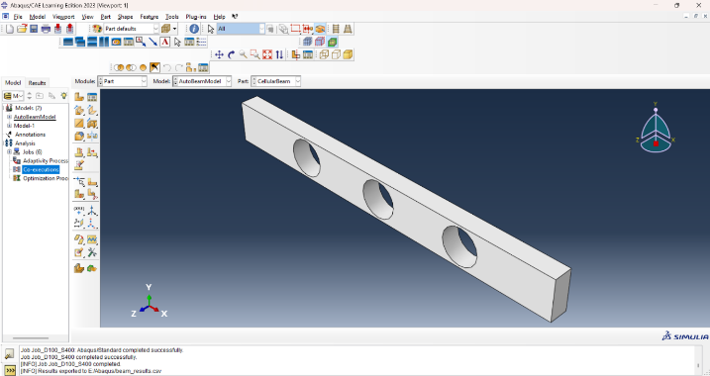
Fig 3.1 Cellular steel beam

3.5 GUI Development
To eliminate the need for manually opening ABAQUS for every test, a GUI was built using Python's Tkinter library [10]. Key features include:
- Input Fields: For hole diameter and spacing (in mm)
- Buttons: For saving inputs, running simulations, and displaying results
- Output Display: Shows extracted stress, deflection, and safety status
- Validation: Prevents simulation from running if fields are left empty or invalid
This interface enables users with minimal technical background to still run simulations accurately and quickly [12].

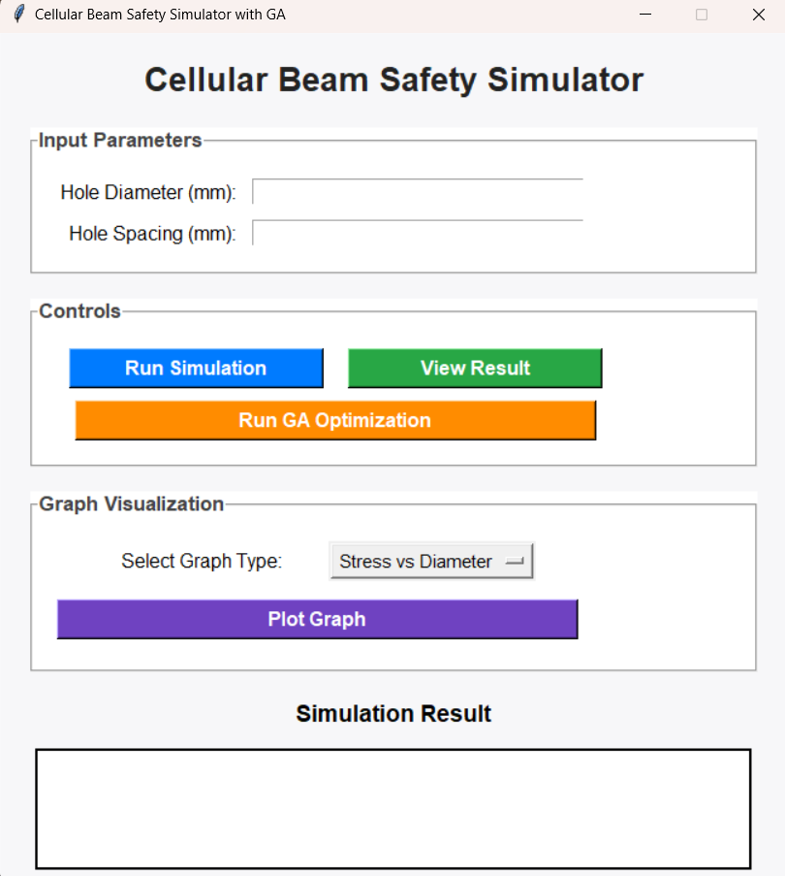

Fig- 3.2 GUI for automated cellular beam simulation system

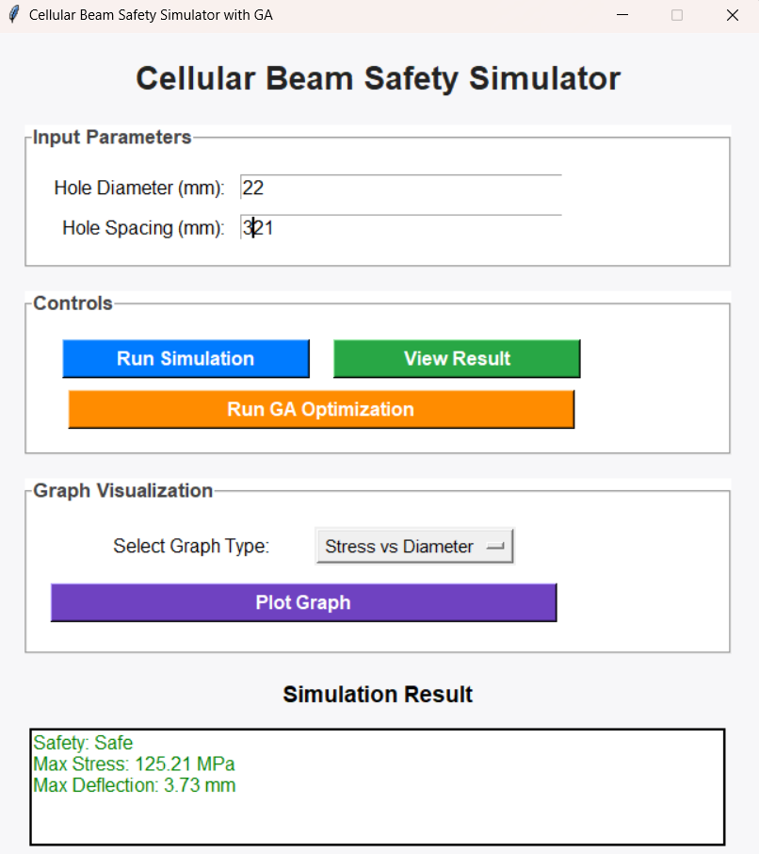

Fig 3.3 – GUI with results

3.6 Optimization using Genetic algorithm

To further improve the efficiency and safety of the beam designs, a Genetic Algorithm (GA) is proposed for future integration. GAs are widely used in structural optimization due to their ability to handle multi-variable search spaces effectively [13], [15], [17].
- Objective Function:
The goal is to minimize beam deflection while satisfying these constraints:
- Max stress < 200 MPa
- Max deflection < L/120
- Hole diameter and spacing within allowed ranges
- GA Implementation Steps:
- Initialization: Randomly generate an initial population of beam designs (pairs of hole diameter and spacing).
- Fitness Evaluation: Each design is simulated, and fitness is calculated as:
f = w₁ × (normalized deflection) + w₂ × (normalized stress)
where w₁ and w₂ are user-defined weights.
- Selection: Best-performing designs are selected as parents.
- Crossover & Mutation:
  - Crossover combines features from two parents.
  - Mutation introduces small changes to add variability.
- Iteration: The process is repeated for several generations until the best design is found.
This approach, based on evolutionary algorithms, provides a structured way to automatically find efficient and safe configurations [16], [18].

RESEARCH DESIGN AND IMPLEMENTATION

4.1 Introduction
In this chapter, the automated system for modelling, simulating, and optimizing cellular beams derived in this thesis is presented. Here, Python scripting and ABAQUS are combined to automate finite element simulations upon the user input parameters. The implementation consists of developing a graphical interface with friendly user interaction, a script for automatic model generation and results extraction, as well as the configuration of an optimization module using Genetic Algorithm (GA). All parts cooperate to facilitate the process of structural assessment, minimize manual work, and enable the quick checking of several openings in the beam cross-sections. In this chapter, we offer a detailed analysis of the system architecture, files input, and parameter management, along with the most salient implementation features, which make the tool lightweight and easy to use, not only in the academic but also in the professional context

4.2 Usage of Python

4.2.1 For automation
In this work, the main task to be done was to automate the finite element modelling and analysis of latticed cellular steel beams in ABAQUS by means of Python.
To speed up the process of creating 3D models, instead of manually designing each model, a series of scripts were constructed to create the 3D beam geometry, set material properties, set boundary conditions, and mesh properties as per user input from within the GUI [5, 6]. Through this automation, the speed and accuracy in testing different design layouts were significantly improved. To facilitate batch simulations without the need for running the interface, the script was developed to invoke ABAQUS in noGUI mode. For each run, the maximum stress and deflection are automatically found by the script, and the information is saved to a CSV file for further analysis [7]. Post-processing of the results was also performed in Python. The script reads the ABAQUS output database (ODB) to extract critical information such as Von Mises stress, vertical displacement, etc. Then, these values were utilized to check the ability of the design to satisfy the safety criteria [8]. Finally, the first optimization framework was developed in the Python language employing Genetic Algorithms. To evaluate performance in terms of stress and deflection, the script modified design variables, such as the hole diameter and hole spacing. This allowed the integration of a full optimization feature with libraries like SciPy [13],[17] in the future.

4.3 Data Collection and Testing
The procedure for gathering pertinent data and running simulations to test different cellular steel beam configurations is described in this section. The information gathered includes the loading scenarios, material characteristics, and geometric dimensions required for precise finite element analysis. The automated system created for this project is used to run simulations, and the results—such as stress, deflection, and safety classification—are used to assess how well various beam designs perform structurally. The sample parameters, testing procedures, and evaluation process are covered in greater detail in the ensuing subsections.

4.3.1 sample Collection
Geometric Properties
Collecting accurate geometric properties is crucial for modelling cellular steel beams. This involves obtaining data on both the overall beam dimensions and the specific characteristics of the cellular configuration:
- Beam Dimensions: Measure the overall length, width, and depth of the beam. These dimensions define the basic structural profile of the beam.
- Cell Characteristics: Document details such as the number of cells, dimensions of each cell (including web thickness, flange width, and height), and the arrangement of cells along the beam's length. These specifics determine the beam's unique structural properties and its performance under various loading conditions.

Material Properties
Accurate material properties are needed to conduct reliable simulations and analyses of cellular steel beams. Using material property libraries or reputable sources to gather the following key parameters:
- Young's Modulus: A stiffness or flexibility-related property of the material.
- Yield Strength: The stress at which the material begins to deform plastically.
- Poisson's Ratio: Proportion of transverse strain to axial strain in uniaxial loading.
Ensure these properties are appropriate for the specific steel grade used in the cellular beams, as different grades exhibit varying mechanical behaviours that directly impact structural performance [4], [9].

4.3.2 Sample size
In order to assess how geometric and loading parameters affect structural performance, a total of thirty distinct beam configurations were simulated in this study. Combinations of hole diameters (40 mm to 100 mm) and hole spacings (200 mm to 400 mm) resulted in different configurations. According to studies like [3], [4], and [17], which look into comparable ranges for web openings in cellular beams, these values were chosen based on standard practice in structural engineering design.

Design Specifications
Important design parameters were systematically changed, including material properties, hole diameter, and spacing. The range that was selected keeps simulation time reasonable while guaranteeing adequate coverage of realistic design scenarios.

Scenarios for loading
To simulate normal service conditions, a constant pressure load was applied in each simulation. To isolate the effects of geometric variation, the load magnitude was maintained constant across all models and was based on standard values for structural testing as cited in [6]. Future research might broaden to encompass different kinds and sizes of loads.

4.3.3 Testing protocols
1. Numerical Simulation-
Finite Element Analysis (FEA) was conducted using ABAQUS to simulate the behaviour of cellular steel beams under various conditions. The following process was followed to ensure accuracy and consistency [5], [6], [7]:
- Input Parameter Definition
  - Geometric parameters (beam length, hole diameter, and space) were determined according to design ranges reported in the literature [3], [4].
  - Material Properties such as Young's Modulus, Poisson's Ratio, and Yield Strength were chosen from standard structural steel [4], [9].
  - Boundary conditions were performed with a pressure load that was made uniform to reflect clinical situation [6].
- Model Creation
  - Python scripts were used to automatically create beam models, apply boundary conditions and prepare property data for ABAQUS [7],[8].
- Meshing
  - 3D C3D8R elements were used in structured mesh, as suggested for solid structural elements with non-linearity [9].
- Simulation Execution
  - ABAQUS noGUI mode was applied to automatically run the simulations in order to simplify and reduce the time of manual interaction [6].
- Post-Processing
  - Simulation results including Maximum Von Mises stress and deflection (U3) were extracted by Python scripts and saved as CSV files for further analysis [8].

- Validation and Evaluation
  - The results were evaluated against conservative thresholds:
    - Stress limit: 200 MPa
    - Deflection limit: L/120
  - These limits were based on safety margins used in related research [4], [17], and the designs were classified as SAFE or UNSAFE accordingly.

2. Optimization Testing-
To identify optimal design parameters, a Genetic Algorithm (GA) was applied due to its ability to explore complex multi-variable spaces efficiently [13], [15], [16], [17]. The following workflow was used:
- Initial Population Generation
  - A random population of design configurations (combinations of hole diameter and spacing) was generated within predefined limits [17].
- Fitness Evaluation
  - Each design was simulated using the automated ABAQUS setup.
  - The fitness function was defined as a weighted combination of normalized stress and deflection values to guide toward structurally efficient solutions [13], [16].
- Selection
  - The top-performing designs were selected to form the next generation using roulette wheel or tournament-based methods [15].
- Crossover and Mutation
  - Offspring were created by combining features from parent designs and introducing small mutations to maintain diversity [13], [16].
- Constraint Checking
  - Each new design was checked to ensure compliance with engineering criteria:
    - Stress < 200 MPa
    - Deflection < L/120
    - Geometric limits based on practical ranges used in design codes [4], [17].

- Iteration and Convergence
  - The GA was iterated until the most efficient and safe configuration was found [17], [18].

4.4 Expected Result

According to the theoretical background and initial studies, optimization and strengthening of cellular steel beams are expected to provide substantial improvements in various important aspects.

Precision in Structural Predictions –
It is anticipated that the developed cellular steel beams would be more accurate in predicting structural responses, including buckling, shear distribution, and bending. Although it is anticipated that the integration of state-of-the-art algorithms and accurate FEA techniques should lead to simulations that are not considerably different from the actual behaviour, minimizing errors and enhancing accuracy

Enhanced Safety Margins-
The optimization process should lead to safer cellular steel beam designs. By utilizing state-of-the-art FEA techniques and optimization algorithms, beams are created that are capable of withstanding loading scenarios without fear of failure. The latter will be revealed by increased thresholds for buckling and other domination modes.

Fewer Design Iterations
A reduction in the number of design iterations to optimum configurations using advanced FEA techniques and optimization algorithms is anticipated. A database-based methodology can allow the systematic presentation and comparison of simulation results, which will help in informed decision-making and optimization [11].

RESULTS, ANALYSIS AND DISCUSSION

5.1 Introduction
In the current section, modelling and automatic simulation of cellular steel beam were carried out using an integrated Python–ABAQUS system are demonstrated. The performance in structural is tested under two geometric conditions: where variations in hole diameters and clearances between holes are taken into account. The proposed approach integrates ABAQUS (6) FEA, together with a Python (8) based GUI [10], allowing the automation of the beam model generation, simulation, and testing [6]. Performance metrics assessed include:
- Maximum Von Mises stress
- Maximum vertical deflection
- Safety classification based on engineering thresholds
These results indicate the robustness of the automated system for predicting structural performance. This chapter provides insight into how geometric changes affect beam operation and to identify critical tolerances and trends. This methodology adds another reinforcement for the effective tool support, which enables engineers to make decisions quickly and based on safety in design [11].

5.2 Simulation outputs
The automated system generates and runs finite element models based on user-provided input values. After each simulation, the system extracts the following key outputs:
- Maximum Von Mises Stress (MPa): Indicates the highest internal stress in the beam. In this study, it is compared against a reduced yield strength of 200 MPa to maintain a conservative safety buffer [4].
- Maximum Vertical Deflection (mm): Reflects the downward displacement (U2 direction) of the beam under load. A relaxed deflection limit of L/120 ≈ 8.33 mm is applied to reflect common engineering practice.
- Safety Verdict: Each configuration is automatically classified as:
  - YES (Safe)
  - NO (Stress), NO (Deflection), or NO (Stress, Deflection) depending on the failure cause(s)
All results are saved to a structured CSV file (beam_results.csv). Each row corresponds to a unique simulation based on the given input parameters. This file can be accessed for direct review or visualized through the GUI to observe patterns across configurations.

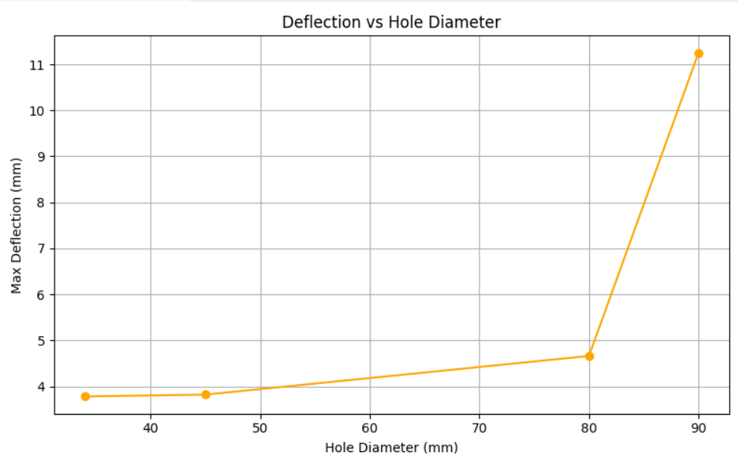
Fig 5.1 Deflection vs Hole diameter

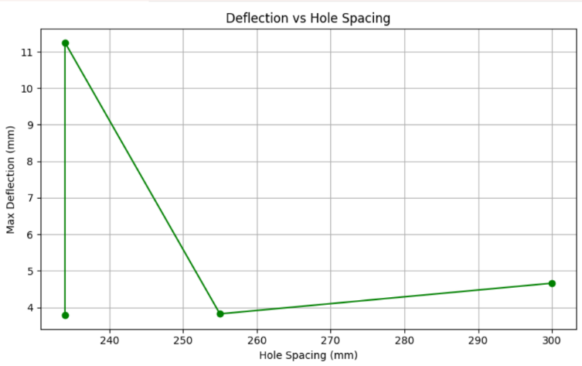

Fig 5.2 – Deflection vs Hole spacing

5.3 GUI Integration
The GUI simplifies the interaction between users and the simulation backend. Key features include:
- Parameter Input: Users enter hole diameter and spacing via entry fields.
- Input Validation: The GUI checks for invalid or out-of-bound values (e.g., overly large holes relative to beam size).
- Simulation Execution: A single button initiates the simulation, which runs in the background using ABAQUS in noGUI mode.
- Result Display: The GUI presents:
  - Safety status (Safe / Unsafe with reason)
  - Maximum stress (MPa)
  - Maximum deflection (mm)
- Visualization Tools: Users can generate plots like “Stress vs Diameter” or “Safe vs Unsafe” to analyze how performance changes across configurations [10].
By abstracting the complexity of ABAQUS and automating result classification, the GUI enables both technical and non-technical users to explore beam behavior intuitively.

5.4 Sample Table Results
Hole Diameter(mm) | Hole Spacing(mm) | Max Stress (MPa) | Max Deflection(mm) | Is Safe
60 | 300 | 172.23 | 2.92 | YES
80 | 300 | 199.14 | 5.65 | YES
100 | 300 | 233.78 | 9.12 | NO (Stress, Deflection)
90 | 400 | 210.55 | 7.96 | NO(Stress)
70 | 200 | 197.90 | 8.20 | NO (Deflection)

Table 5.4 – sample result table

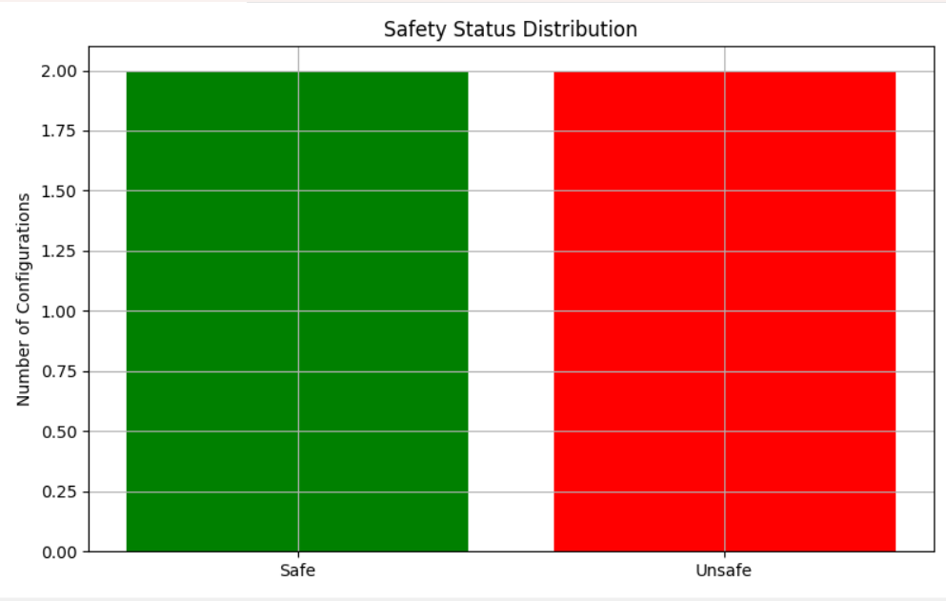
Fig 5.3 – Safe vs unsafe results
5.5 Result Interpretation
The results reveal consistent trends in how geometric configurations affect beam safety:
- Stress Sensitivity: Larger hole diameters increase localized stress around the web openings, often exceeding the 200 MPa threshold. Configurations with hole diameters ≥ 90 mm show higher stress risks.
- Deflection Trends: Spacing also impacts stiffness. Reduced web continuity from closely spaced or large holes leads to greater deflection, sometimes breaching the 8.33 mm limit.
- Combined Failures: Several cases show simultaneous violations in both stress and deflection, especially in configurations with both large diameter and minimal spacing.
- Design Thresholds: For example, increasing the diameter from 60 mm to 100 mm (with the same spacing) can shift the design from safe to unsafe, indicating a narrow margin for failure.
- Automation Benefits:
  - Fast iteration of multiple configurations.
  - Automatic validation and result classification.
  - CSV output and graph visualization for deeper analysis.
These insights prove the practical value of the developed tool in helping structural engineers design cellular beams more safely and efficiently. The automated logic behind verdict generation (e.g., marking NO for stress or deflection) eliminates ambiguity, making the tool accessible even to users without deep FEA experience.

Parameter | Limit Used | Justification
Yield Strength (MPa) | 200 | Lowered to test safety limits
Max Deflection (mm) | L/120(=8.33mm) | Relaxed serviceability criterion

Table 5.5 - Threshold Comparison Table

CONCLUSION

6.1 Introduction
By providing an overview of the work completed and emphasizing significant discoveries from the creation and testing of the automated cellular steel beam simulation system, this chapter brings the study to a close. The system's performance is also covered, along with how optimization techniques, graphical user interfaces, and finite element analysis are integrated. It includes suggestions for future enhancements and possible system extensions, as well as a brief comparison with earlier research.

6.2 Future work
Although the current system effectively automates the modelling and safety evaluation of cellular steel beams, there are several opportunities for future enhancement. A key area of improvement is the integration of a Genetic Algorithm (GA) module, which would enable automated optimization of beam design by intelligently selecting hole diameters and spacing to minimize deflection, stress, or material usage, or to meet multi-objective performance criteria. Additionally, the graphical features of the application could be expanded to include dynamic plots that update in real-time as simulations are run, offering users deeper insight into structural trends. Future versions of the system could also allow users to modify more advanced parameters, such as beam length, support conditions, load magnitudes, and material properties, offering greater flexibility and control over simulation scenarios. Moreover, adding functionality to automatically generate a comprehensive PDF report—complete with input data, simulation outcomes, safety evaluations, and graphs—would be highly valuable for academic and professional documentation. Finally, converting the current standalone desktop GUI into a web-based application would significantly increase accessibility, enabling users to perform simulations without requiring local installations of ABAQUS or Python.

REFERENCES

[1] A. S. Elnashai and D. Izzuddin, Advanced Analysis of Structures, 1st ed. London: CRC Press, 2010.
[2] C. J. Earls and M. S. McGuire, “Elastic stability of cellular steel beams,” J. Constr. Steel Res., vol. 58, no. 11, pp. 1441–1461, 2002.
[3] H. Abdelrahman and M. Hassan, “Behavior of steel cellular beams with sinusoidal openings,” Alexandria Eng. J., vol. 56, no. 1, pp. 173–183, 2017.
[4] N. E. Shanmugam, B. V. R. Reddy, and M. N. Reddy, “Behaviour of cellular beams under various loadings,” J. Struct. Eng., vol. 132, no. 3, pp. 345–352, 2006.
[5] ABAQUS, User’s Manual v6.14. Dassault Systèmes Simulia Corp., 2014.
[6] H. Yehia and H. Helou, “Finite element modeling of steel beams using ABAQUS,” Adv. Mater. Res., vol. 83–86, pp. 1201–1208, 2010.
[7] D. Kumbhar, “Automated finite element modeling in ABAQUS using Python scripting,” Int. J. Sci. Eng. Res., vol. 7, no. 5, pp. 78–83, 2016.
[8] T. Kiran and A. Shankar, “Parametric analysis and scripting in ABAQUS using Python,” Proc. Int. Conf. Comput. Model. Eng., pp. 134–139, 2018.
[9] Z. Xiang, Y. Chen, and J. Liu, “Simulation of complex steel beam behavior using ABAQUS,” Int. J. Struct. Civ. Eng., vol. 4, no. 2, pp. 45–51, 2013.
[10] N. Mahdavi and A. El-Belbol, “User interfaces for civil engineering simulation tools,” Int. J. Eng. Res. Appl., vol. 5, no. 4, pp. 13–17, 2015.
[11] A. Hosseini and M. Torkaman, “Comparison of manual and automated finite element modeling,” Int. J. Adv. Struct. Eng., vol. 8, no. 3, pp. 267–275, 2016.
[12] M. Alam and S. Khan, “Development of GUI-based civil engineering analysis tools using Python,” Int. J. Eng. Innov. Technol., vol. 8, no. 9, pp. 99–103, 2019.

[13] A. Kaveh and S. Talatahari, “Optimal design of skeletal structures via imperialist competitive algorithm,” Comput. Struct., vol. 89, no. 23–24, pp. 2416–2427, 2011.
[14] H. Adeli and S. Kumar, “Neural network model for optimization of steel structures,” J. Struct. Eng., vol. 121, no. 12, pp. 1588–1595, 1995.
[15] Y. Chai and F. Cheng, “Genetic algorithm-based structural optimization,” J. Comput. Civ. Eng., vol. 14, no. 2, pp. 143–150, 2000.
[16] A. Rajan, “Sizing, shape, and topology design optimization of trusses using genetic algorithm,” J. Struct. Eng., vol. 121, no. 10, pp. 1480–1487, 1995.
[17] M. Saka and M. Doğan, “Metaheuristics in optimum design of cellular beams,” Struct. Multidiscip. Optim., vol. 62, no. 5, pp. 2319–2335, 2020.
[18] A. Marjanović, M. Jurić-Kaćunić, and K. Jambrošić, “Hybrid algorithms for structural optimization,” Eng. Struct., vol. 176, pp. 802–813, 2018.
[19] J. S. Arora, Introduction to Optimum Design, 4th ed. Academic Press, 2017.
[20] G. R. Liu and S. S. Quek, The Finite Element Method: A Practical Course, 2nd ed. Butterworth-Heinemann, 2013.
[21] L. J. Gibson, “Cellular solids in structural engineering,” J. Mech. Phys. Solids, vol. 35, no. 4, pp. 489–512, 1987.
[22] T. T. Soong and M. Grigoriu, Random Vibration of Mechanical and Structural Systems. Prentice-Hall, 1993.
[23] A. R. Sanayei and F. Jaishi, “Structural health monitoring using optimization and sensor networks,” Comput. Civ. Infrastruct. Eng., vol. 21, no. 3, pp. 239–247, 2006.
[24] A. K. Noor and J. M. Tanner, “Computational strategies for finite element analysis,” Comput. Methods Appl. Mech. Eng., vol. 35, pp. 189–224, 1982.

Appendix A - GUI CODE

Appendix B Automation code

Appendix C Optimization with ga code

